Chapter 4 “Plants” Review Notes:
Plants are autotrophs!
We know this because they make their own food AKA photosynthesis. Plants collect the energy they need for this from the sun.
Plants are multicellular!
We know this because plants are made of tissues-groups of similar cells that perform a specific function in an organism.
Plant cell are different from animal cells! The two biggest differences include the cell wall and chloroplasts:
Cell wall- separates the cell from the environment. The cell wall contains cellulose which makes it rigid.
Chloroplasts- where food is made (photosynthesis)
Vacuole (larger in plant cells)- stores food, water, and waste for the cell.
WATER IS IMPORTANT!
The cuticle & stomata of the leaf helps the plant retain (hold onto) water.
Transpiration- water loss through evaporation
Many plants need water to reproduce (joining of the sperm and egg cells)-for some, this can only occur if there is water in the environment.
Characteristics of nonvascular plants: Do not have vascular tissue for transporting materials, Low growing, Thin cell walls, Do not have roots
Example: MOSSES
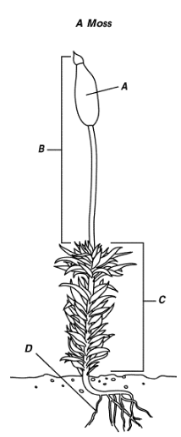
A: capsule- contains spores B: sporophyte (capsule and stalk) C: gametophyte (leaf-like structures)
D: rhizoids- anchor the moss and absorb water & nutrients
**Over time, mosses may compact into layers and form a material called peat.
Vascular tissues:
Xylem- moves water and nutrients
Phloem- moves food down from the leaves
The xylem is responsible for the age rings on a tree.
Seed plants-have vascular tissue and use pollen & seeds to reproduce.
Types of seed plants:
Gymnosperms- “naked” seed. (naked = not enclosed in fruit)
Angiosperms- flowering plants with seeds incased in fruit
Dicot- 2 seed leaf
Monocot- 1 seed leaf
Cot is short for COTYLEDON which means seed leaf.
Plant Life stages:
Sporophyte- produces spores
Gametophyte- produces sperm and egg cells (sex cells)
Fertilization- when the sperm and egg cells meet.
Vascular seedless plants- spread spores, NOT seeds
Example: Ferns
Ferns grow in damp and shady areas. They need water in order for the sperm cells to join the egg cells.
Too much sun will make the fern weaker and eventually die.
Response and growth
Tropism- a plants response toward (positive) or away (negative)
Thigmostropism- touch
Gravitropism- gravity
Phototropism- light
Seasonal change
length of night and day is photoperiodism
Darkness determines the flowering times of plants. Why we have spring only flowers, summer only, etc.
Dormancy- prepares plants for freezing temperatures and the lack of liquid water.

